**Feedbacks for Referral Network by Client**

**Notes for future added functions to be added at bottom.**

**YELLOW HIGHLIGHT IS COMPLETED ITEMS**

**Green Highlight is follow up to item**

**2021-11-20**

**Open Street Maps account -** [**stewart@stewartpeddemors.com**](mailto:stewart@stewartpeddemors.com) **D,f$q%A'g=Pxt9U Could we use this instead of Google Maps for the API. 2022 Follow up**

**2021-11-16**

**227. One test message was sent to a real agent who sent an email back saying not interested. Email is below. The issue is that we should not have any test emails going out of the system directly to the agents until we are ready to launch. You can use myself as the test request agent** [**stewart@stewartpeddemors.com**](mailto:stewart@stewartpeddemors.com) **or Sissy Deng or Jennifer Kudryk who are default agents on the map. That will make sure any accidental emails escaping before launch would be directed to myself or my team.**



|  | **Sender notified by**  [**Mailtrack**](https://mailtrack.io?utm_source=gmail&utm_medium=signature&utm_campaign=signaturevirality11&) | **21-11-16, 09 h 23 min 55 s** |  |
| --- | --- | --- | --- |



**Le mar. 16 nov. 2021, à 07 h 52, <test@samosys.com> a écrit :**

**Hello Luc Gaudreau,**

**Thanks for being part of My Referral Network. I have a client who would like you to reach out and connect with them to help them find a home in the Postal Code area G6B-Lac Megantic,G6G-Thetfford Mines Centre.**

**If you want the referral click the link Accept. If you do not want the referral click Decline. If you accept you will be sent the name, phone and email of the client right away so you can reach out to them.They are looking for you to connect with them.**

**By clicking Accept you will agree to pay the sender a 25% referral fee upon a successful transaction. Accepted referrals may not be passed on to another agent unless they are informed of the referral fee owed to the sender.**

[**Accept**](http://localhost:4500/request/178/1) [**Decline**](http://localhost:4500/request/178/2)

**Your Referral Network Partner,**

**Stewart Peddemors Personal Real Estate Corporation**

**RE/MAX Colonial Pacific Realty Ltd**

**604-329-6759**

**stewartp@remax.net**

**Samosys: [TBD] No further email will go to realtors until we are live.**

**2021-11-14**

**226. Everytime I update a default agent their profile is turned off in the Public Map. When I changed my picture the program turned myself off in the FSA areas that I am the default agent in. I turned myself back on in each area and then updated my photo again and it did the same thing. When a profile is updated it should not turn the Default status off. There should be no effect on the status of the agent when updates occur. Also when I went back in the second time to turn myself on the program the pop up says it is changed but the profile does not turn back on right away. There is a lag in the time that shows it is turned on. It appeared to me for a few minutes that it was not turning on.**

**Samosys :[ Done 15-11-2021] While updating the profile Default agent status will not change .** I just tried changing photo again. I changed my picture and I was turned off in all the areas I was assigned default Status. V4B, V9K, V9P See photo below of V4B. It is the same for V9K and V9P. I was no longer showing on the public or realtor maps. 2021-11-17

**Samosys 19-11-2021: You have an updated profile from Frontend or Admin ? I was updating from the admin panel. 2021-11-19 I just updated my photo again and I was taken off the map again. All areas where i was th default agent I have been turned off in the FSA. Also on the public page the request me button was removed on the right hand panel on my profile see updated photo below. 2021-11-19**

**Samosys 21-11-2021: Sorry for the inconvenience . While updating the profile Default agent status will not change , you can check now .**

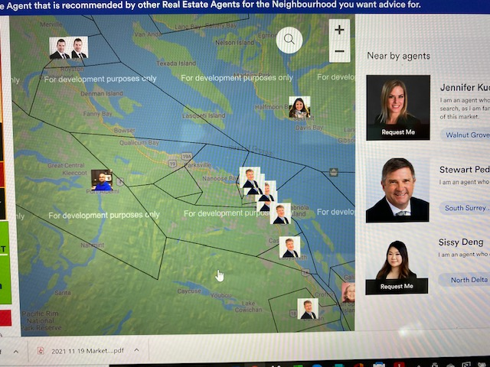

**2021-11-13**

**225.** Not sure why this email would be sent out to a Partner Agent when they are part of the System already. This was when the customer requested the Agent and the agent accepted the referral. The email below was sent out as well. When clicking OPEN FORM in the email the link went to a page that was not working properly. it did not go to a form. Not sure what that form was to be about? updating their information I am guessing?? **This email would come from a Client Agent when they want to add a new agent of their choice to the system or to add an agent to their map who is already part of the system.**

***Email that came in after a customer requested for a default agent / partner agent that was in the public page.***

**Hello Sissy Deng,**

**I would like you to become part of My Referral Network. I will be happy to work with you for my referrals in V4C-North Delta,V4E-Sunshine Hills,V4G-Delta Burns Bog,V4K-Ladner,V4L-Beach Grove Tsawwassen East,V4M-Tsawwassen West,V6V-Richmond North East,V6W-Richmond South East,V6X-River Rock,V6Y-Brighouse Broadmoor,V7A-South Arm,V7B-Airport Sea Island,V7C -Thopson Seafair,V7E-Steveston. Click on below button to fill in all your information for being my Partner agent, so we can connect with each other quickly.**

[**Open Form**](http://103.15.67.78:3087/partner-agent/f950f7ec-1436-4cd0-aa76-0bcccce3fa11)

**Your Referral Network Partner,**

**Realtor Name: Sissy Deng**

**Realtor Brokerage:**

**Realtor Phone Number: 778-996-7738**

**Realtor Email:** [**sissydeng@remax.net**](mailto:sissydeng@remax.net)

**Samosys :[ Done 18-11-2021] Can you again check request email content ?**

**224. When an agent is requested in one FSA area all the FSA area that the agent is in shows as requested. Is there a way to request again if needed.**

**Samosys 15-11-2021 : Send request again after 14 days. We have not managed requests for every FSA. We manage like if a customer sent a request to an Agent then he will be able to send a new request after 14 days. What if a customer, realtor or client wants to send another referral to the same agent. Or they wanted to just connect with them again to connect.?? 2021-11-17**

**223. When I updated the photo of Stewart Peddemors in the Admin panel then Stewart Peddemors profile in the FSA areas he was default agent in turned off and was no longer showing on the Public Map. Changing Agent information should not turn off the default status.**

**Samosys :[ Done 15-11-2021] While updating the profile Default agent status will not change .Samosys :[ Done 15-11-2021] While updating the profile Default agent status will not change .hhh dhisd dbns See 226. The profile keep turning off in all the default FSA areas and it removed from the public maps**

**2021-11-12**

**222. When receiving the referral form from the system and clicking on the accept button, I was taken back to the My referral network map with the link. How is the information sent to the agent when they accept and what happens if they decline the referral?**

**Samosys : Are you talking about Request Me ? Or Realtor comes from the Join us link ? It was the request me email sent to the realtor when requested by the customer. it has the “accept” or “decline”. I did see later that an email was sent to me with the information I was looking for. I did not know how the information was being sent and because it was not immediate I did not know how it was being delivered. Maybe when “accepted” is clicked then a pop says “An email has been sent to you with Client details.” if declined then a they can be taken back to the main page.**

**Samosys :[ 18-11-2021] Can you again check request email content ?**

**2021-11-11**

**221.** Changing from Partner Agent to Client Agent - I found myself again as a partner agent so I was updating myself to client agent. The Confirmation pop up is worded incorrectly. There should be no reference to default agent. It is a partner agent signing up to become a client. **The wording should be “ You are a Partner Agent. Do you want to become a Client Agent so you can create your own Map?” YES / CANCEL.**

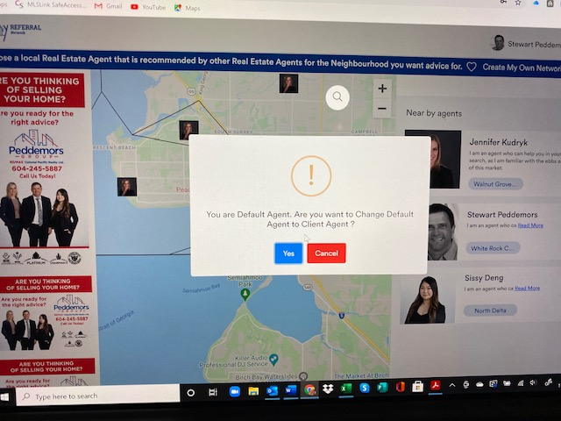

When I get through the payment portion and it redirects me back to the Site I try to create my own map but it does not allow me to and sends me back to the signup page. I did check the admin page and it does have me listed as a client now. I check the public page and refresh the map and I have disappeared from the public map in the 3 places I was the default agent. I check the FSA areas and I have been removed from the FSA area and do not show up in the FSA admin Panel when I become a client. **Being a Client or not should have no impact on the Map default agents.**

**Samosys[TBD]**

**2011-11-10**

220. Customer requesting agent link incorrect. The request page for a customer appears to be working wrong. **I logged in as a customer.** I tried to request an agent with the request me button. The form that came up looked good but the wording in the left box was the “partner agent creation wording” not the “customer wording”. The two emails that came through from the customer requesting help by an agent, were the ones that are to be mailed to an agent to be created to be the partner agent for a “Client” Realtor. There has been a mix up again on the site. This was supposed to be fixed before but obviously was changed again.

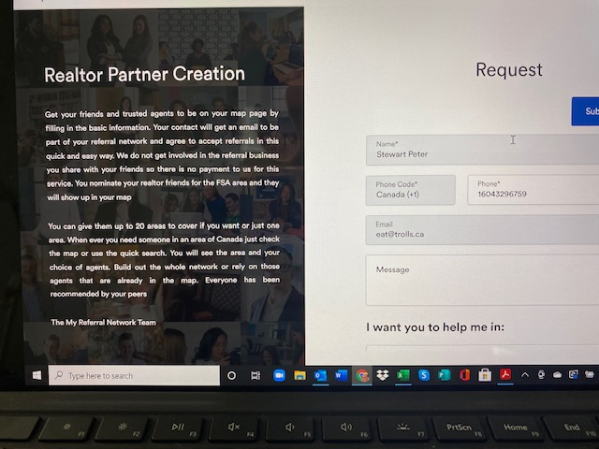

**The two emails received by the “Customer request for help in a FSA area” that is supposed to send a message to the agent requested for help in the area from the Customer coming from myself as the referring agent with the do you want to accept/decline. The emails I received was “ Hello Admin, Stewart Peter has Successfully sent new request to join the network.**

**Stewart Peddemors 16043296759** [**eat@trolls.ca**](mailto:eat@trolls.ca) **regards, Team Refferal Thank you.” Spelling and language is not correct even if it was for a request to join.**

**Samosys :We have changed the Request Page left box content . Please check if this content is correct ? Content is now correct in box below. 2021-11-12**

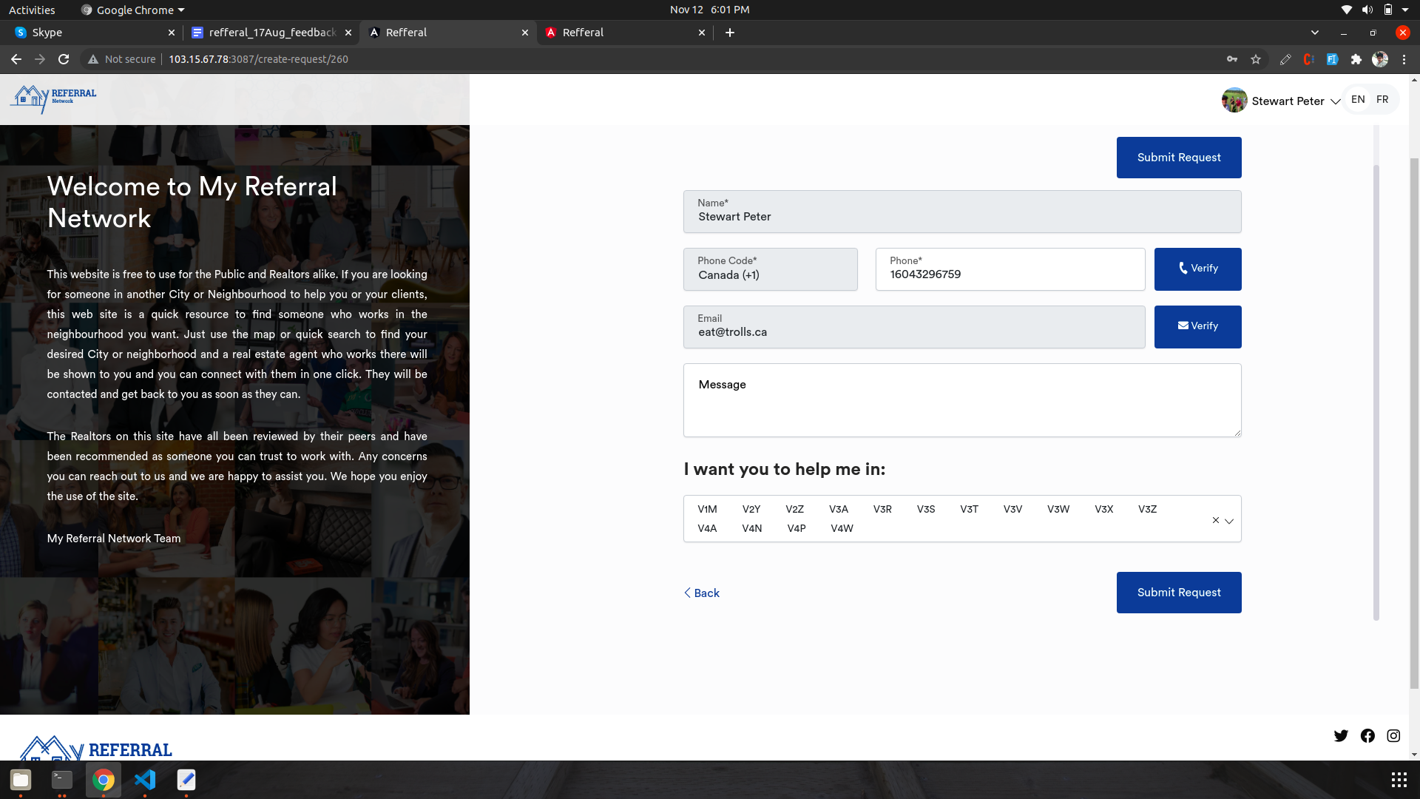

**Samosys: We have changed Email content . Please check if mail content is correct ?**

**We are using this email** The email Below would be for when a **New Realtor** signs up to the network as a partner so their profile can be reviewed by the admin to make sure and confirm that they are a real estate agent.

**When a new customer signs up it would read as follows.**

Hello Admin,

A new customer has signed up and joined the My Referral Network and has been verified.

The Customer name is _______________ name insert here___________.

The customer phone ______insert phone here ______ has been verified.

The customer email _____ insert email here________ has been verified.

At your service,

The My referral Network Team

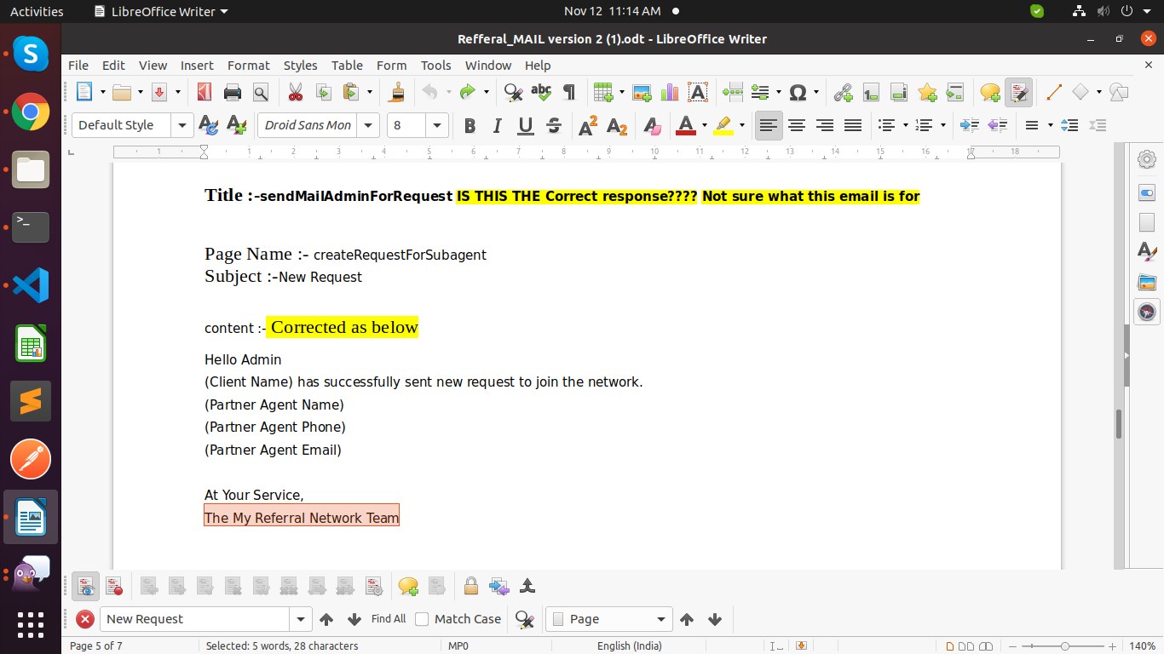

**The email below is the email that is sent out to any agent who is requested by the customer user when clicking the request me button**

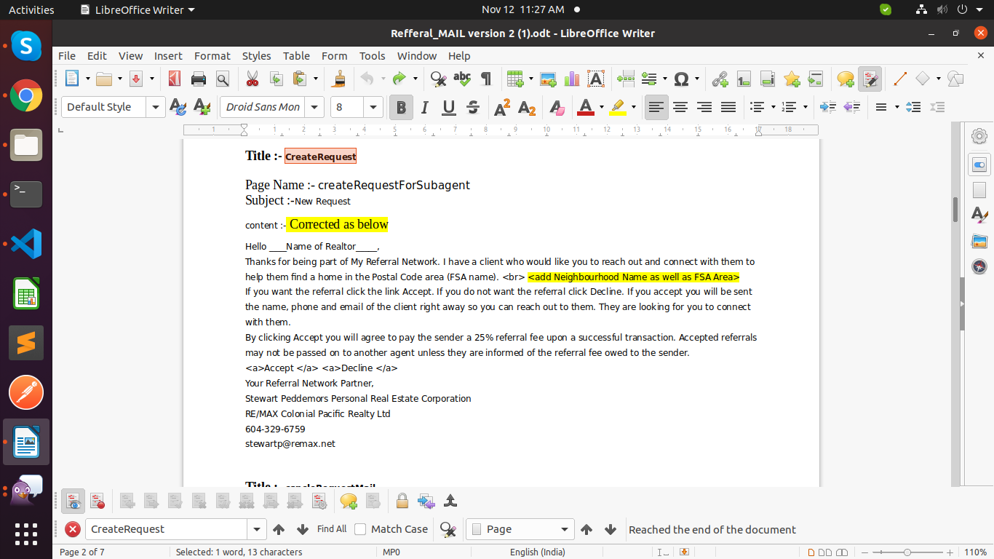

**The Email below is not correctly worded. This is the email to notify the Admin that a request for an agent has been made by the consumer. The Email should read as follows and have the following information contained in the email for the admin.**

**Title “ Customer request notice to admin”**

**Hello Admin,**

**Customer Name: ______name insert here___**

**Customer Phone: _____phone insert here___**

**Customer Email: ____email insert here**

**has requested a Realtor to help them in FSA _Insert FSA here___ ,Neighborhood name ____insert neighborhood name here___.**

**Please contact the Agent to confirm they received the email.**

**Realtor Name: _____________________**

**Realtor Phone: _____________________**

**Realtor Email: _____________________**

**At your Service,**

**The My Referral Network Team**

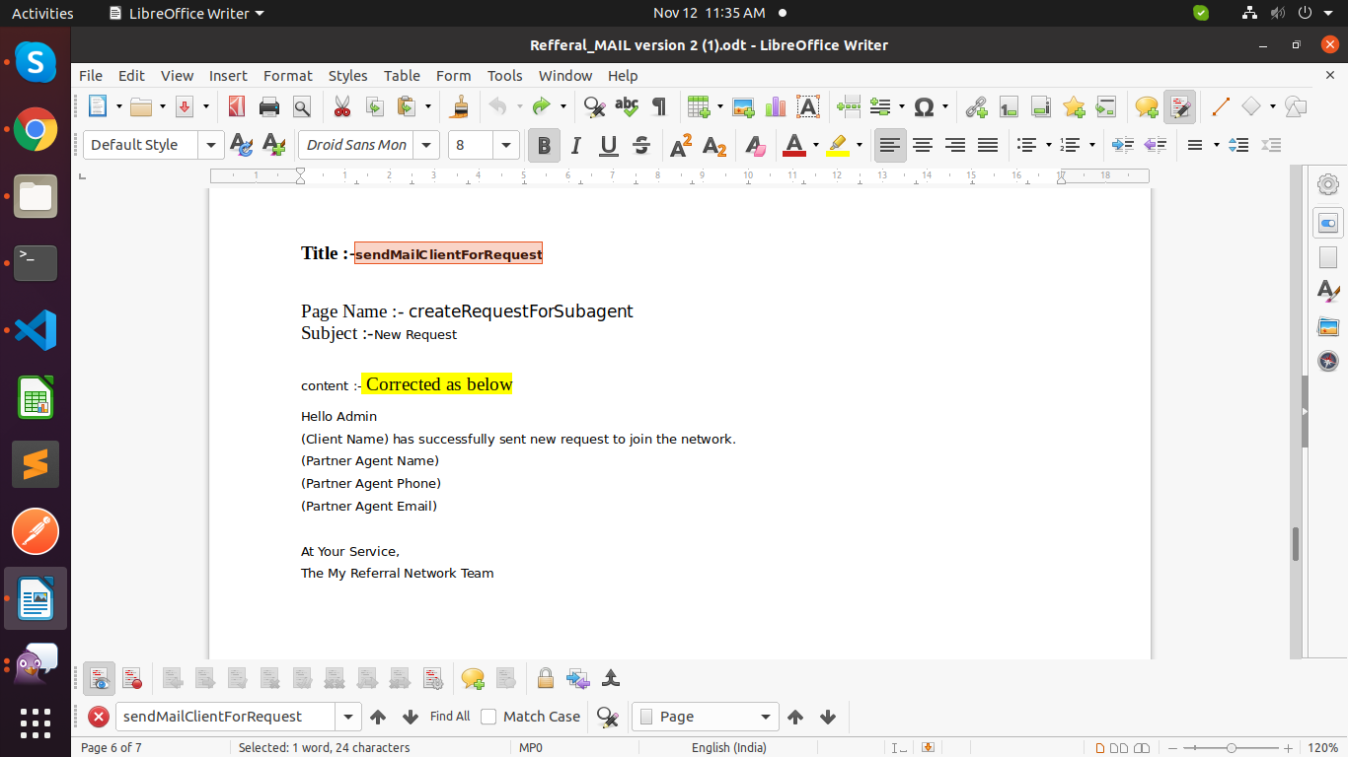

**Please correct us if we are using wrong mail content. See the content above.**

**2021-11-13 I sent a request today from a Customer for an agent to help them out and this was the email received by the admin. This is not the right email message but close . The yellow highlight is the real error as a client cannot join the network. They are asking for help in and FSA area. see the email wording above to correct. Titled as “customer request notice to admin”**

**Hello Admin,**

**Stewart Peter has successfully sent new request to join the network.**

**Partner Agent Name: Sissy Deng**

**Partner Agent Phone: 778-996-7738**

**Partner Agent Email: sissydeng@remax.net**

**At Your Service,**

**The My Referral Network Team**

**Samosys :[ 18-11-2021] Can you again check email content ?**

**219. I signed up again as client Agent. I looked and saw that I had replaced Jennifer Kudryk on the Map in her area V4A and V4P. I should not be replacing her on the Public map as I am not the default agent for that area. I am only the default agent for V9K, V9P and V4B. V4B is the only one in this picture. the two other spots are V4A and V4P which should be Jennifer.**

**Samosys : If a Client agent replaces any agent on his map , then only that FSA agent is replaced . It will not affect any other FSA.Can you please check ?** When I went back today to have a look Jennifer was back in her two spots but I was removed from the maps as being active. I had to go to each of the FSA areas V9K, V9P and V4B to turn my profile back on. This has occurred before when changing to client status. **When changing from Partner to client agent this should not effect the default agent status in FSA areas where the agent is the default agent. 2021-11-13**

**Samosys 14-11-2021 : [TBD]**

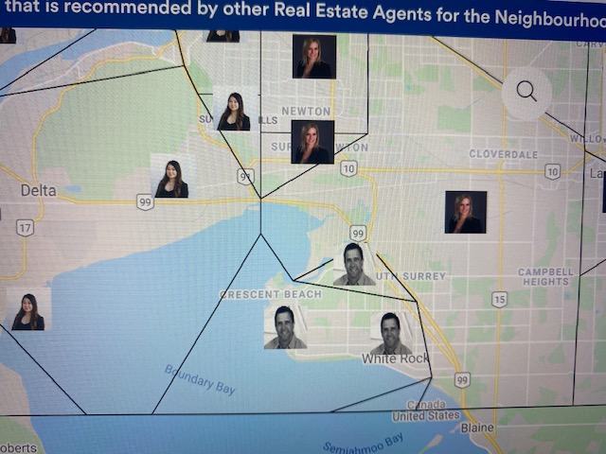

**218. Noticed I was back on map in one FSA area and had to turn myself on in another area that I went missing in. I went to the Client file and I was no longer listed as a client but listed as a partner agent.  
Samosys : I have a one question**

**If a client agent is marked as a Default agent then we need to display this agent in Partner's list or in client agent list in admin ? Maybe we can simplify this somehow. Being a default agent for any FSA has not correlation to being a Partner or Client. The only difference for a Partner or Client is that the Client can create their own map. Being a default agent for an FSA is only tied to that FSA. A partner or a Client can be a default agent in one FSA and not a default in another FSA. Take myself and my profile for example. I am the default agent in 3 FSAs (V9K, V4P and V4B) but I am also listed as an agent in more FSA (V4P ect.) which I am not the default agent.**

**Here is an idea. Keep all agents in the partner agent list. This list is then the main list to update any realtor who joins as a partner agent or as a client. Anyone who signs up as a client is tagged and then listed separately in the client list as well. Then the system will work with the whole list for populating the FSA areas. Does this sound good or is there a better way? 2021-11-10.**

**Samosys: If you select a Client agent as a Default agent in any one FSA then the Client agent will be a Default agent in that FSA and in the remaining FSA , he will be a Client Agent.**

**You can see that client agent in the Client agent list in Admin. The client agent default status gets turned off for some reason when changing from Partner to client in FSA areas. This was also noted above in 219. 2021-11-13**

**If you select Client Agent as a Default agent then client agent will be showing in Partner agent list and as well Client Agent list in Admin.** OK so the client will show up in both lists. That is ok by me. If any status is changed to the FSA of one profile the other profile should also change. Correct? 2021-11-13

**Samosys 14-11-2021: Yes ,**If any status is changed to the FSA of one profile the other profile should also change. That is good. 2021-11-17

**217. I went to update photo for myself and it would not accept the photo change. I could change the photo but it would not save. Tried to hit update button but no update would occur and no updated notice would come up.**

**Samosys :Can you please share me image In both Profile and in admin the update for photo is not working. I can get to change the photo but when i hit the update button it does nothing.**

**Samosys : Can you please try again ? Please upload an image with extension . I tried both admin and by profile and it is not giving the update successful notice. You can hit the update button but nothing happens,. 2021-11-11**

**Samosys :We have fixed it , Can you please check it again ?** Update in Admin now working. Update in Customer profile is working but **not in Client profile.** Client profile still does not get the update successful pop up. Check Realtor partner profile as well to make sure they all work. 2021-11-13

**Samosys 14-11-2021: Can you share your client credentials ? Its working in our end .**

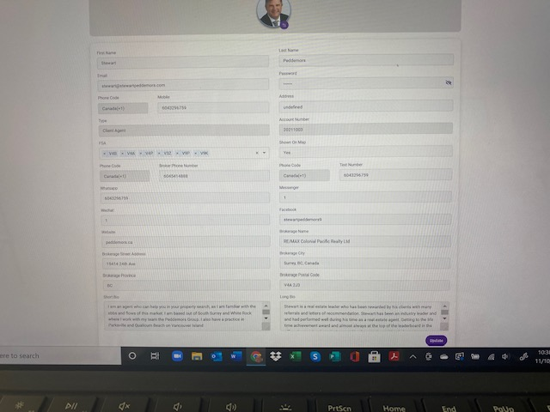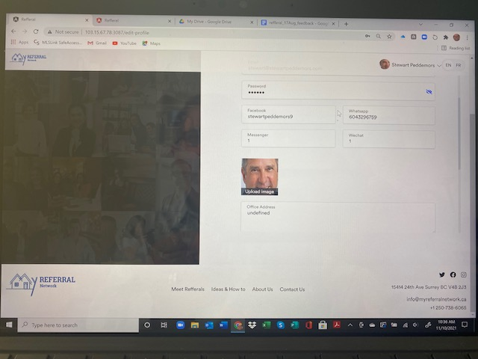

**2021-11-08**

**216. Error in Postal CODE GA6 should be named G6A as the FSA code.**

**Samosys : Done**

**2021-11-02**

**215. As pers 213 below I am not on the map but I saw a small picture in a weird location that came onto the public map. It was for V9K. The agent who is the back up for that area was populated to the public map which is good when a default agent goes missing but the link went to the original location of the FSA point not the updated spot that is in the FSA admin panel. It did not load up in the updated location which it should and also the picture size would have been bigger. Also Ian Lyndsay was turned off in the FSA so it should not have shown up on the map. It should have been turned on automatically when there is no other agent. See note below I**

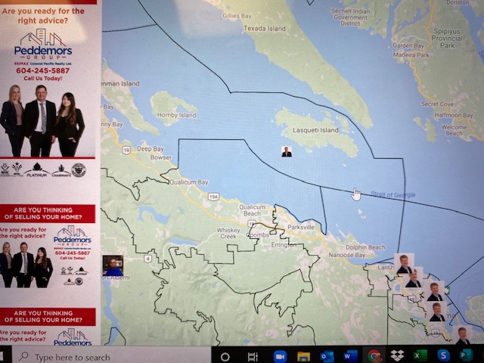

**Samosys : You can see Stewart Peddemors for FSA V9K in the image below.** Yes i was reinstated to V9K. See note above in 218 I had to turn myself on in the V9P. Until I turned on myself to be default agent for V9P the little box with Ian Lindsay was still showing. The issue is more that the little box appeared in the wrong location and it was also turned off at the same time in the FSA. We will have to do tests when the default agent is removed and another agent is in the FSA and takes over - what happens to the view and how does it show up in the public / realtor map and the admin FSA panel. Ian Lindsay is still showing on the map while I am the Agent listed as Default for V9K. He should not be showing on the map unless made default agent. 2011-11-10

**Samosys: We have fixed it , now Lan Lindsay will not appear on map on V9P FSA.**

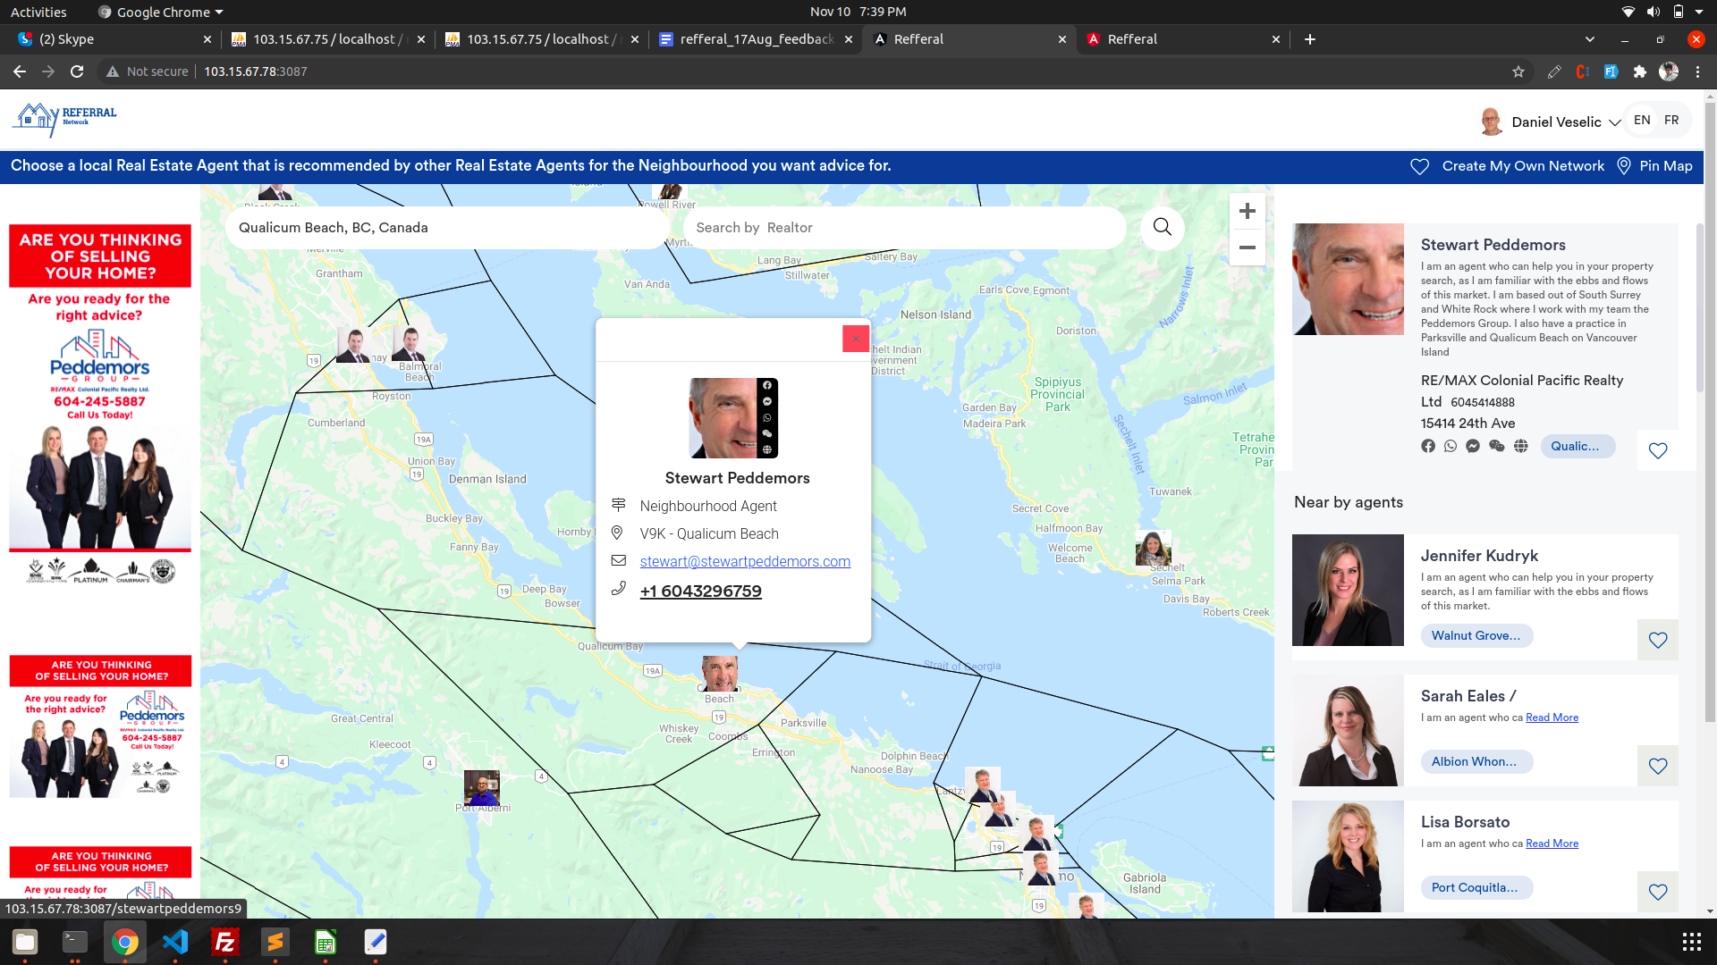

**2021-11-02   
 Samosys we have done optimization on map, is it loading fast at your end now ? It is much better now. Loading in about 20 - 30 seconds rather than 2 minutes. realtor photos still loading slower but way better than before. Working very good for admin panel now. Still loading slowly for public site with photos. 2011-11-08 Still close to one minute to load all pictures on my side. Much better overall. 2021-11-09**

**Samosys 10-11-2021:** We are working on a picture loading issue.

**Samosys :We will check this , when code is deployed on your production server.**

**2021 -11-01**

**214. Small and Large Bio. How does it work in the Systems? Please describe.**

**Samosys : By default small bio will be visible , when we click on Read more button then long bio will be visible .**

**213. When I signed up as a client from my profile, I had some challenges. FIrstly not all the data fields are in the sign up as noted below in item 210. I made it through to the payment system which worked. The admin received a message to say I had signed up. When I went to the map I noticed that I disappeared from the map which should not happen. Then I went to the admin Panel and looked myself up. The password field was empty? Was that supposed to be empty? Also only the large Bio is showing up and not the small or large bio’s. We may need to rethink this as a separate item. When I first looked at the entry page I noticed my Neighbourhood name had been changed to undefined. Then I went into the map and noticed I was no longer in any of the FSA areas. I went to the admin page and noticed that I was no longer marked in any FSA area.**

**Samosys:** [**Done] We have imported client agents in the fsa detail page . Admin can select any client as Default agent. There are no clients at this time. I did sign up as a client and now I am not a client. I will sign up again and see what happens.**

**Samosys: We are working on it again**

**Samosys:** [**Done] We have imported client agents in the fsa detail page . Admin can select any client as Default agent.**

**After selecting the client agent as a Default agent then the agent will start to appear on the map.**

**You can see your password in the password field.**

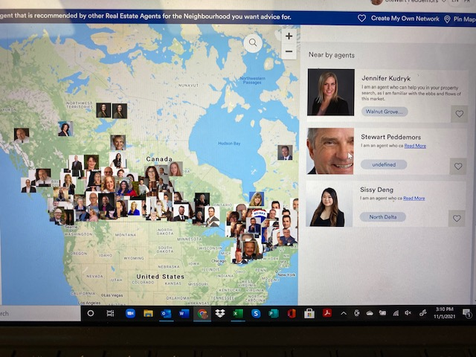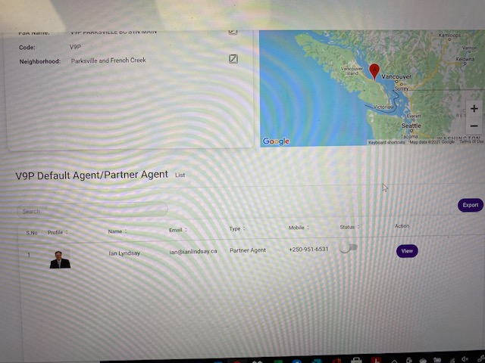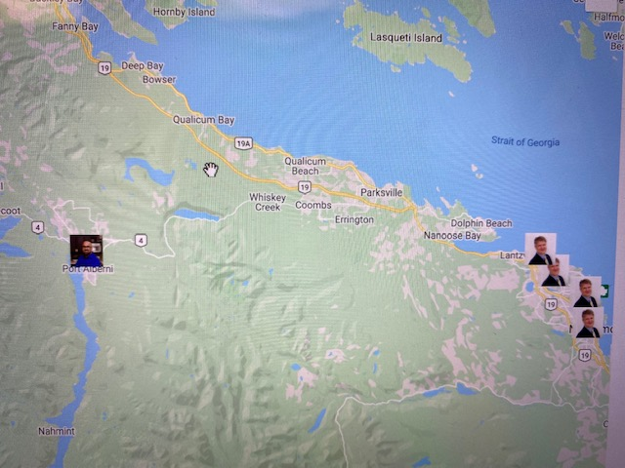

**From 2021-08-21**

1. Client Agent tab is for those who have paid for a subscription. It has nothing to do with default status. These people can amend their own map. A default agent may or may not be a client agent.

**Samosys:** [**Done] You will have to walk me through the subscription process for an agent to become a client. Or how the admin can upgrade a Partner Agent to a client. 2021-09-01**

**Samosys : We have not made any logic on how Admin can upgrade Partner Agent to Client Agent . Can you please tell us , How to achieve it ? There is no need for the admin to change the profile.** Any current agent or new agent subscribing to be a partner agent should be able to change themselves to a client agent. This is done by the “Create my own network” button. They sign up and pay their annual subscription. They then become a client agent. **What I was looking for was** to be able to get a current partner agent to be able to update their information. At this time, I should be able to send a current partner agent their existing profile or link of their existing profile to add any information that is missing. When they fill in all the information and confirm it correct they will be directed to the “partner agent” page. The information is automatically changed in the system for any changes they have made. They can then decide if they want to upgrade to become a client. **This was the same link** I was looking for with all the profile data to update. **I don’t want them to sign up a second time as a partner agen**t but I want them to take control of their own profile. They can change to a client agent at anytime.

All I need is a link which we have been working on but the **link is connected to their profile**. **This would be similar to the automatic link that is contemplated in the original scope for agents to receive an email with a link to their profile to verify and update information once a year.** This email would be sent to all agents in the system once per year to update and confirm their information. One idea could be the automation set up to be completed but also a second option could be in each profile in admin we could add a “request to update” button which when clicked by the Admin it would send out the update link to their file at anytime. This would be helpful if the Admin notices a change between the yearly automatic emails. 2021-11-13

**Samosys 15-11-2021 : [TBD]**

**2021 - 10 -31**

**212. Agent has gone missing from Map again. Yesterday when we looked at this area the agents were all there and today Jeff Meyer is missing. I had taken him off one area as the default agent and after that he was taken off all the spots on the map. He should still be showing in all these areas and only removed from the one area as default. I had to go into each FSA area to turn him back on manually. When an agent is turned off as default agent for one area it must not affect the other areas that he is default agent. All the other areas he would still be the default agent.**

**Samosys:** [**Done] Can you check again . They are all back but I will keep checking when realtor Statuses are changed. It seems to be when we are updating an agent in their profile that they sometimes get turned off in the FSA areas they serve. This should not happen.**

**Samosys 14-11-2021 : Done Default agent will not turn off now while updating agent . This happened again on 2021-11-19**

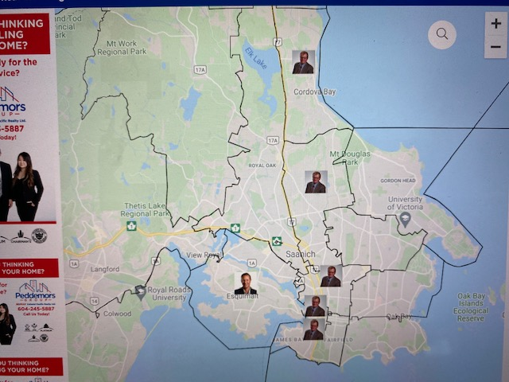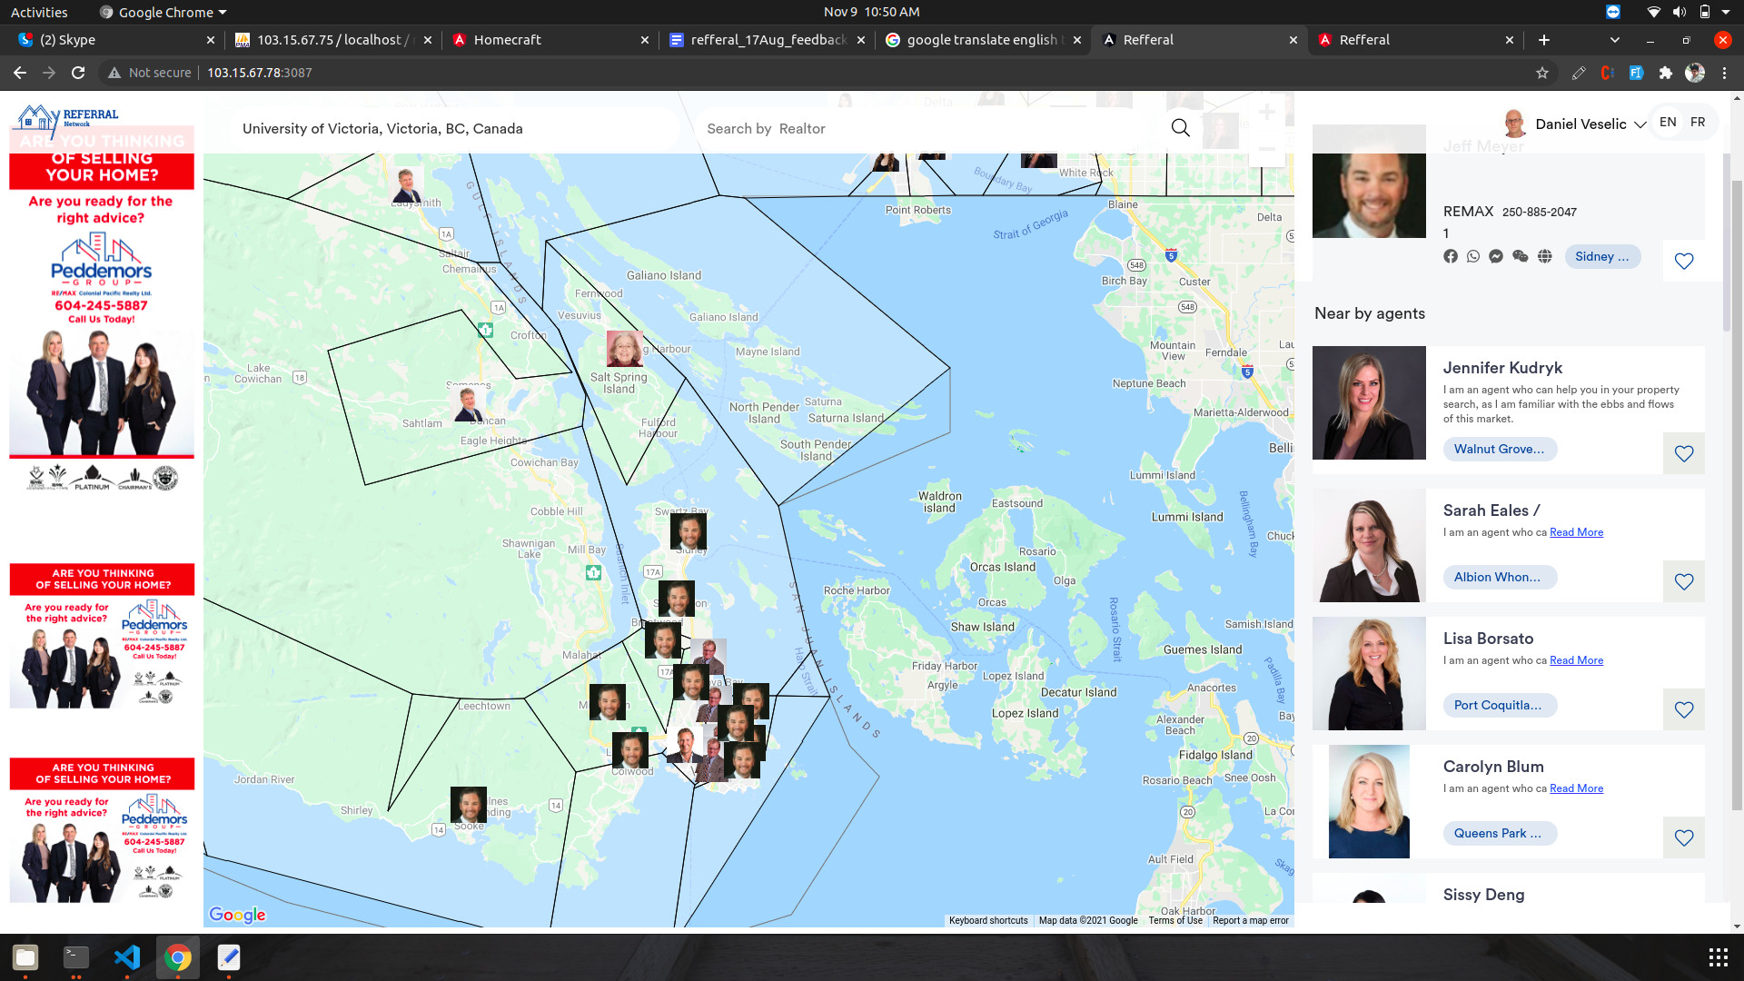

**211. No map on admin panel. All Grey color. Map came back on a few hours later??? not sure what happened to the system but this needs to be checked.**

**Samosys:** [**Done]**

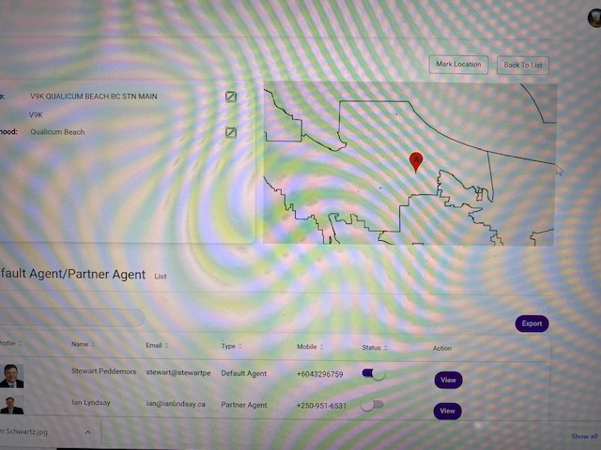

**2021 - 10 - 30**

**210. The linked form to send to an agent does not have all the fields to be filled in for when an agent signs up. All the fields in the bottom form should be in the sign up form. They cannot change “Agent Type, Account number, Country code for phone numbers.”**

**Samosys:** [**Done] We have added some fields to the join us page.**

**Biography when filled in the first 20 (or 100 spaces and characters) words automatically become the short Bio and the remaining Bio is opened up when the “more'' button is clicked. The only items that are not required to be filled in are Facebook, Whatsapp, Wechat, Messenger. Samosys:** [**Done]**

**Also when a client or partner agent looks at their profile they should be able to update any of the items in the form. This information should not affect their login information. That would be stored separately. We need to make sure there is a double authentication whenever a person is changing their password or login name. Either with an OTP and having to fill in the password twice. The Profile email that is on this form can be changed and not effect the login or account of the agent.**

**Samosys:** [**Done] All fields are added in the update profile page for client and realtor.  
 We have not added change email from frontend in this scope.**

**We have added password authentication if an agent update their name or password.**

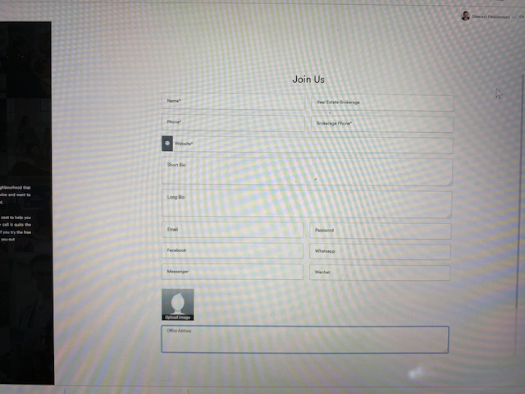

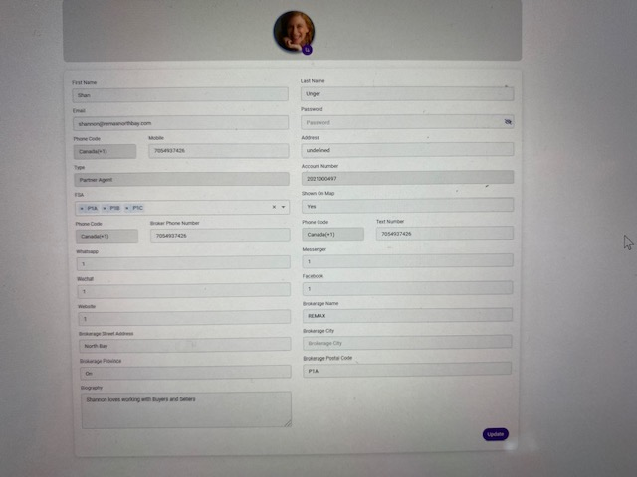

**206. Added Realtor gone missing from list and map. Trying to add back in and system not allowing as it says email already exists but the realtor profile is not showing up in the Client or Partner list (Kelsey Smith** [**contact@kelseysmith.ca**](mailto:contact@kelseysmith.ca)**) I did notice for some reason she has an email in contact us tab. That should not effect being able to add an agent. It seems to be the same issue as item 205 to add back an agent. It also could be that it is a bug in the system and even though they are already in the system they are not appearing in the Realtor list for some reason.**

**Samosys** : You can see Kelsey Smith in the Client list.   
 Admin can edit email of any agent.  **she is not showing up in FSA areas she has in her profile. 2021-11-08**

**Samosys: Now you can see ,Kelsey Smith is now showing in the admin panel.**

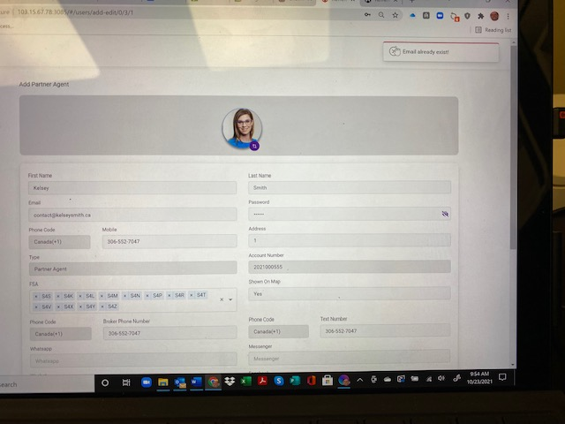

**2021 - 10 -22**

**203. If we can begin to to back up loads to my FTP site for safe keeping as per the contract.**

**2021-10-19**

**105. Timing of site loading issues: I know we are still developing but we do need to make the site work faster. Site needs to have to look at more lazy loads, and properly resize the images that we want to display. As a suggestion is that we need to store thumbnails in the database, along with the larger images. The site is pulling what looks like over 200 mg of data, which is a lot to work with to speed up the process. We should fix this issue before you move on. It really makes it slow to work on the site. There is a javascript that runs way to long, and a very slow loading json file. (over 2 mins for the Canadian_FSA.geojson). This was the lines that I was talking about yesterday being added to the map. These are items that need to be addressed or people won’t use the site as it is too slow. Thanks for the help on this.**

**Samosys**: [**Done]** we have optimized the website and the website is loading fast . Still need to show how fast it runs. **Much improved 2011-11-08 Photos of agents still load too slow but mapping and functions working much quicker now. 2011-11-08**

**Samosys :We will check this , when code is deployed on your production server. Sounds good**

**117. How does an agent or consumer check their account to update phone, email, picture, password or other contact information? There should be a link to their account so they can update their own account. Samosys**: [**Done] Not Fully functional see item 210 as well 2021-11-08**

**Samosys:** We have added all fields . Email is not on the client or agent profile to be able to be changed? **What happens if someone needs to change their email? if they change email it will become their new sign in name with the password. 2021 11-22**

**Samosys 14-11-2021: We are using email as a unique key that’s why we have not given functionality to change the email . If necessary then we can make logic for that? See blue note balove**

**120. Agent FSA disappearing when adding other agent. When I added Kelsey Smith to the System and placed her in some FSA’s she showed up on the map but the Realtor (Brenda Jackstiet) who was in those spots disappeared from the Map in all the FSA areas. All the areas became blank. When I went to the public map all the FSA’s had been removed. When I went to the FSA’s in the Admin panel some of the FSA mapping was in the ocean and not where it belonged. WHen I remapped the FSA the agent still did not appear. See photo above for missing spots. This is occurring all over the country and needs to be addressed.   
 Samosys : Have you added agent from Admin OR Web ? I added agents from Admin. None from Web yet. Still testing database for errors before I start going through the Client functions.**

**Samosys**: [**Done 21-10-2021] Can you test it again. Kelsey Smith is still not showing up in the FSA areas in the admin panel and she is an active partner agent. It appears she now has many more than 20 FSA areas given to her and that her agent information has been changed by one of the developers. She cannot be added to the maps. The account needs to be looked at and why it doesn't show up. 2021-11-08**

**Samosys: Now you can see ,Kelsey Smith is now showing in the admin panel.**

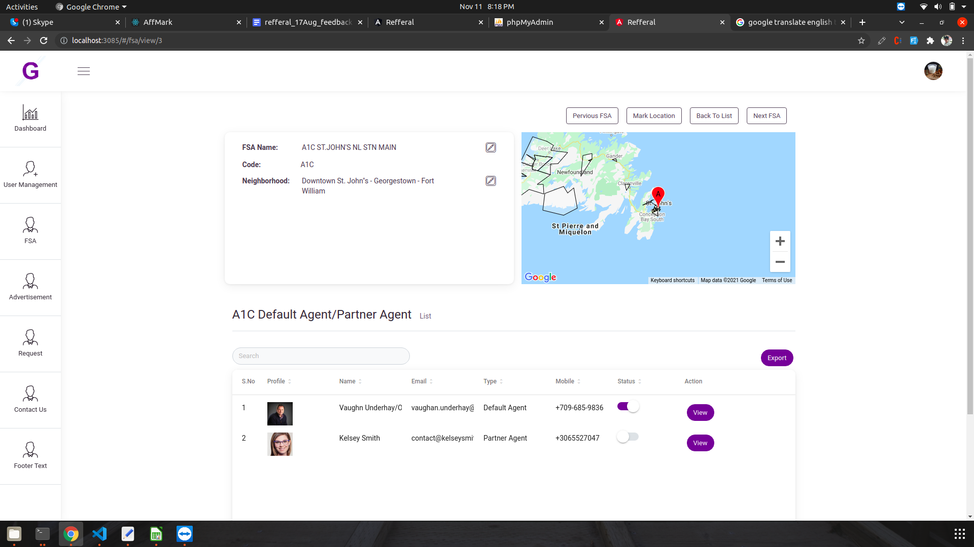

**100. I am currently listed as a Partner Agent and I want to change to Client agent through the system. I tried to test the sign up and it allowed me to login as a Realtor login and when I hit the Make my own network button it allowed me to change the map without becoming a client agent. I had not yet signed up to change myself to a client agent and have not been able to get to the Payment links to test. Any Realtor ( Partner) login should be able to upgrade to Client and I can’t seem to find a way to do that at this point in time. We will have to go through the process with both existing Realtors in the system and new agents as they sign in as both Realtor login or go directly to client login right away.**

**PAYPAL Information for Developer**

**Samosys : This is connected to our developer account.Please share your Paypal credentials , so we can use them. Is this what you wanted.**

NVP/SOAP Sandbox API Credentials

**Username:**

**sb-h0qal6963042_api1.business.example.com**

**Password:**

**JE6MEPMZN65JQAKL**

**Signature:**

**Auu605Mx8P5Wuj69kZA0aV5uAnXfA71yJ175oNjmLli84pACfndEwQez**

## REST Apps

**Samosys**: [**Done] 21-09-2021 Paypal link to your account.**

**ADMIN Page CLient AGENT**

**99.**  The Default agent should be handled in the FSA tab where the list of agent who are requested or referred into the FSA would show up. The Admin can change who the default agent is in this tab. If a default agent quits the person with the most agents using them for this area then they would become the default agent. The agent quits when their email bounces back or they click no to receiving a referral from the system.

**98.**  Email System built in for automatic emails. We will have to go over all the email systems to make sure that the correct sequence and emails are occurring. You can see the original If this then that PDF to see what happens when an action occurs. If needed I can attach in skype for easy access again.

**97. 2021-08-24**

**The relationship between Default Agent / Sub-Agent and Client agent / Partner Agent needs to be discussed for the system to work. You may not be getting the idea quite right and wanted to follow up so we don’t go too far in programming the wrong way.**

**All Agents are a Client agent or Partner agent but not both. Right now we have no Client agents but I will promote a couple of Realtor Partners to Client for testing. Right now the only ones I want to be Client agents are Stewart Peddemors, Sissy Deng, Jennifer Kudryk with Dave Cousins and Krista Blankley being the 5 test Client Agents to start**

**For now all the other agents are considered Partner agents. A client or a partner agent can be either a Sub-agent or Default agent depending on the FSA. THE FSA each runs separately and agents can be a default agent in one FSA but not the default agent in another FSA. . They will be Sub-agents for all the areas they request unless the admin makes them the Default agent or the system promotes the Sub-agent due to an agent being retired or quit. I have provided a list of default agents to start the map. All those agents would be partner agents and there was a few of the agents that were marked as sub agents in the data base. We don’t need to use the old data base but can start adding to the existing database to keep up with some of the changes I have made.**

**96.** Over all map does not need line borders on public or realtor maps. Only needed on admin side and maybe not even needed there at this point in time.**Samosys[TBD]**

**95. FSA Admin Page**

This is where we need to clarify and discuss so that we get the functions working between Default agents and Sub-Agents. This is being confused a bit by Client Agents and Partner Agents and just want to make sure you are not wasting time on heading the wrong direction.

I see the idea of the FSA Admin page to have three components.

First box (FSA Box)is the list of FSA’s - This box has the # of the FSA - The FSA 3 digit with name - The FSA Description and the Status button on/off. When an FSA is highlighted or clicked on the box to the right will display the FSA results. The Second box (The Agent Box) beside the FSA List has the list of agents nominated for the FSA area. At the top of the box is the default agent Name. There will need to be a button to change the Default agent. If clicking on an agent their information should pop up. Below the Default Agent would be the list of Sub-Agents and the number of times they have been recommended for the location. Also if their name is clicked their information would pop up. The third box (The Map Box) below should show the map and the location of the FSA on the map. It should zoom down to local FSA level. The pin on the map that locates the FSA POP up will show up and in the future the admin should be able to correct the location on the map. For now We may have to find a way to correct a few FSA locations as they just don’t make sense or we will have to turn them off for now.

**Samosys**: [**Done]23-09-2021 When a client agent changes from a partner agent they get removed form the map if they are a default agent. There is no correlation between default agent and client agent. 2021-11-08**

**Samosys[TBD]**

**94. August 21 2021**

Clients Creating their own map is not functioning yet. This the the main piece of the web site

that will help everything else fall into place .

**Samosys**: **[Done] The clent map is now working correctly. see item 3 below for functioning of adding realtors to my referral network map when signed in as a client. 2021-11-01**

**93.** When clicking on change to my own agent there is nothing that it goes to.

**Samosys**: **[Done] I will need to walk through this I don’t see the button to change to my own agent. 2021-09-01 I have seen the name change but the function is not working correctly. 2021-09-12**

**Samosys**: [**Done]21-09-2021 - Where the agent is the same as a default agent on the public or realtor map there needs to be a button on the pop up when signed in as a client that allows the default agent be added to my network map. There should be no need to change agent and add the same information. Only when an agent is not in an FSA pop up then the client would have to populate the field of change to my own agent 2021-11-06**

**Samosys : When we clicked on change to my agent button , A popup opens for agent information.If agent exists in over Refferal system then we will not send join us link for adding remaining information.If agent is not exists then we will send join us link to that agent.**

**Please check ?** Please send link for verification purposes 2021 -11 -22

**92.** This layout for the admin dashboard would work better for the layout. We can chat about the items in the dashboard on our next meeting.

**Samosys: [TBD]**

91. FSA tab on admin.- This is where the default agent status is determined. There should be two panels on this page. The first panel is already on the page but as discussed on Saturday there should be a spot for the default agent name to be listed with the FSA. The second panel would be the opened FSA listing of all agents that have been recommended for that FSA. When you click on the first panel and pick the FSA the second panel will change to the FSA you are viewing. Their would be two sections in this panel. Showing the current default Agent and then all the other Partner agents below ranked by the number of people recommending them. Only one agent can be marked as default agent for each FSA. When a default agent quits or no longer wants to receive referrals then the next agent with the highest number of recommendations for that FSA will become the default agent automatically. I will send an example of the layout.

**Samosys: [In Process TBD]**

**90**. I was asking for a link to start getting realtors to upload their information. I want to send the upload link to about 6 agents who know about my projects and I want to test the automatic form for agents to use to add their information and pictures.

**Samosys: [Done]   
Please use this link :** [**http://103.15.67.78:3087/join-us**](http://103.15.67.78:3087/join-us) **Thanks for this link. The link should have all the database fields in it to be filled out. The full profile. Short Biography, Long Biography, contact information, web page links, photo etc. that are all part of the profile for the agent in the system. 2021-09-01**

**Samosys**: [**Done]21-09-2021 2021-11-08 The link still does not have the full profile to be filled in.**

**Samosys**: 11-11-2021 We have added all fields . **This is the link I was referring to in 213. point 1. In regards to sending the existing Partner agents a form to fill in and update their existing information.**

**Link created to allow partner agents currently in the system to update information 2022-11-22**

**New Ideas List Keep to bottom. Phase 2 projects**

1. **Admin To be able to Place a second bubble in some FSA areas that are large and have two or more service centres that could use a different Agent. We could add as many bubbles as needed for an FSA area.**
2. **To add to 40 FSA for all agents.**
3. **Ad space for right hand panel before login or using map.**
4. **Mass email system integration with City Email. Automatic agreement for double opt in to receive emails**
5. **Auto follow up of lead referral**
6. Should all the profile pictures that are showing up as round balls be the same look on the map when viewing. pictures showing up as the square. Not an issue but does look better as circles. For Later on additions.
7. if an agent signs in the box on the left side can pop their profile up with Jennifer, Sissy and Stewart. They will see it as value to them when they are always appearing on the side panel. That will remain until they pick an agent and the program goes into the FSA display mode of agent and nearby agents.

**89. 19-08-2021**

1. Partner Agents would not show up on map listing or on right side. Only the default agents show up on the public map and the realtor map as they cannot change the maps. The only time that map changes is for client users. One exception and that is for the Realtor user or partner if they sign in as a realtor and not a client their information would be posted to the areas they serve instead of the default agent.

**Samosys: [TBD] To be added in second phase**